Advanced Linux Lab

DATE: 13-02-21

NAME: RAJUL DUBEY

SAP ID: 500069424

EXPERIMENT :2.2.2 Backups in Linux

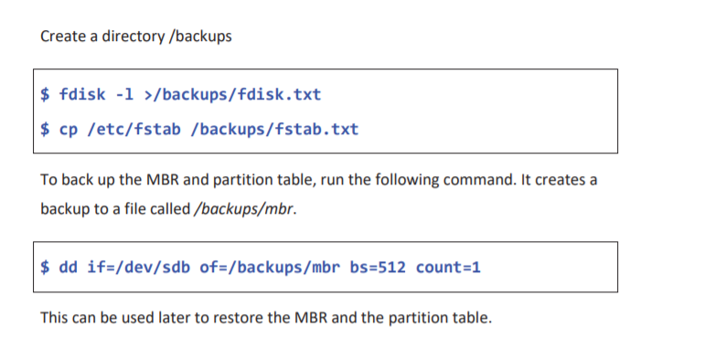

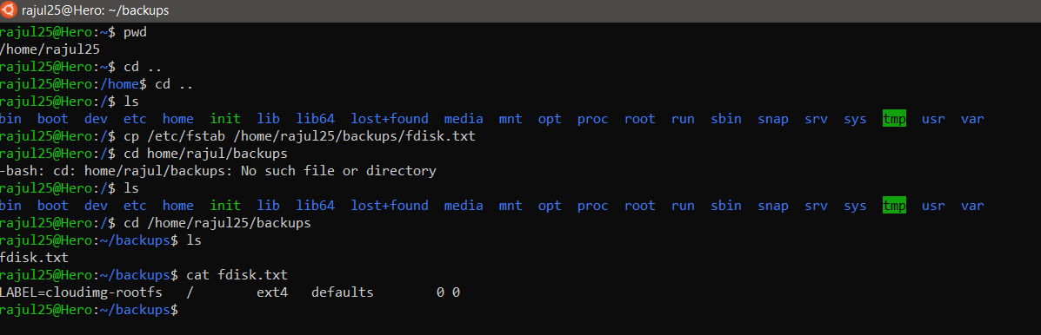

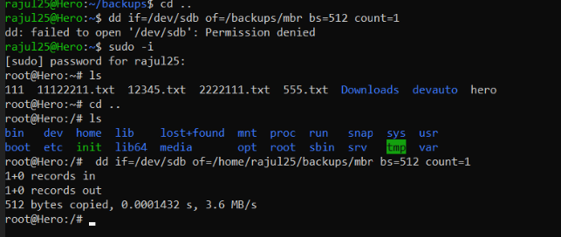

EXPERIMENT: 2.2.3 Syslog in Linux

**Syslog** in Linux Log files related to daemons and system processes are located in the /var/log directory. These log files use a standard protocol called syslog, handled by the syslogd daemon. Every standard application makes use of syslogd to log information. This recipe describes how to use syslogd to log information from a shell script.

**Lab:** The logger command allows scripts to create and manage log messages: Place a message in the syslog file /var/log/messages:

